Name : Dev Adnani  
SID : 202212012

Subject : Systems Programming

Assignment : 9

1:

202212012_Lab9_1.c

#include <stdio.h>

#include <stdlib.h>

#include <string.h>

#include <pthread.h>

#include <unistd.h>

#include <math.h>

struct startEnd

{

int start;

int end;

};

double sroot[100];

void *sqrRoot(void *nos);

int main(int argc, char *argv[])

{

pthread_t threads[10];

int *threadsReturn[10];

int err;

printf("Main thread id %u is starting \n", (unsigned int)pthread_self());

int start = 0, end = 9;

struct startEnd stE;

for (int i = 0; i < 10; i++)

{

if (i != 0)

{

start = end + 1;

end = start + 9;

}

stE.start = start;

stE.end = end;

err = pthread_create(&threads[i], NULL, sqrRoot, (void *)&stE);

if (err != 0)

printf("Can't create the thread: %s\n", strerror(err));

err = pthread_join(threads[i], (void **)&threadsReturn[i]);

if (err != 0)

printf("Can't join the thread : %s\n", strerror(err));

}

for (int i = 0; i < 100; i++)

{

printf("Square root of : %d is %.2lf\n", i, sroot[i]);

}

printf("Main thread is %u exiting\n", (unsigned int)pthread_self());

pthread_exit(0);

}

void *sqrRoot(void *nos)

{

printf("thread id %u is starting \n", (unsigned int)pthread_self());

struct startEnd *thread_p = nos;

printf("Thread with Two Params: %d :: %d\n\n", thread_p->start, thread_p->end);

for (int i = thread_p->start; i <= thread_p->end; i++)

{

sroot[i] = sqrt(i);

}

printf("thread id %u is exiting \n", (unsigned int)pthread_self());

pthread_exit(0);

}

Screenshots :

Q1-A

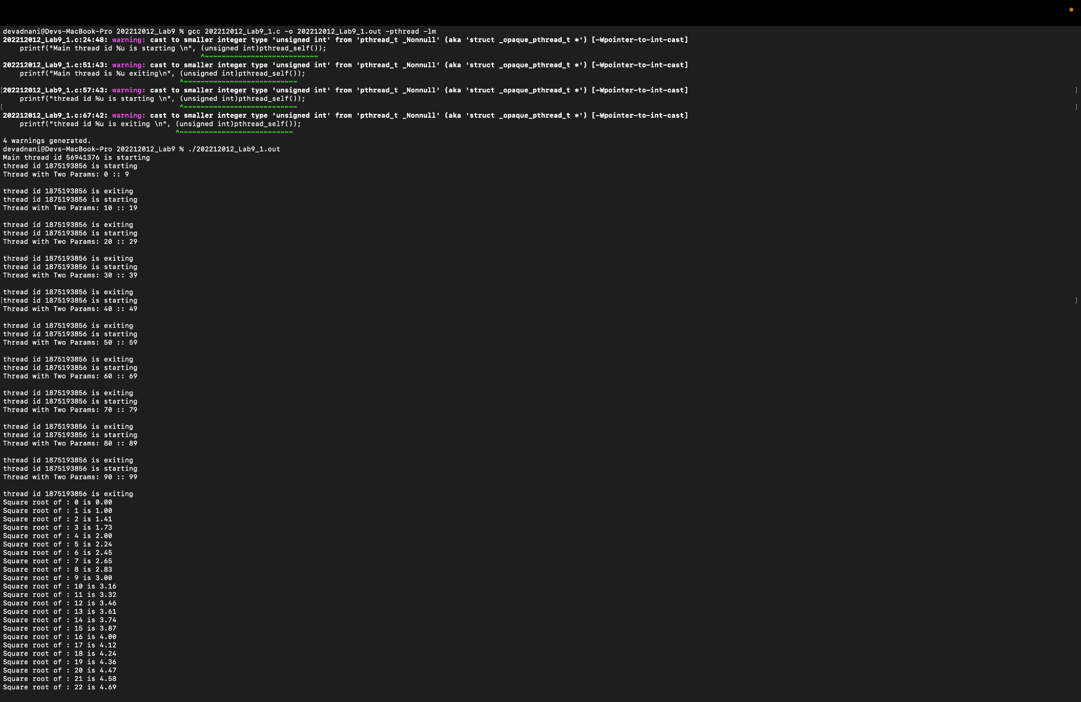

Q1 - B

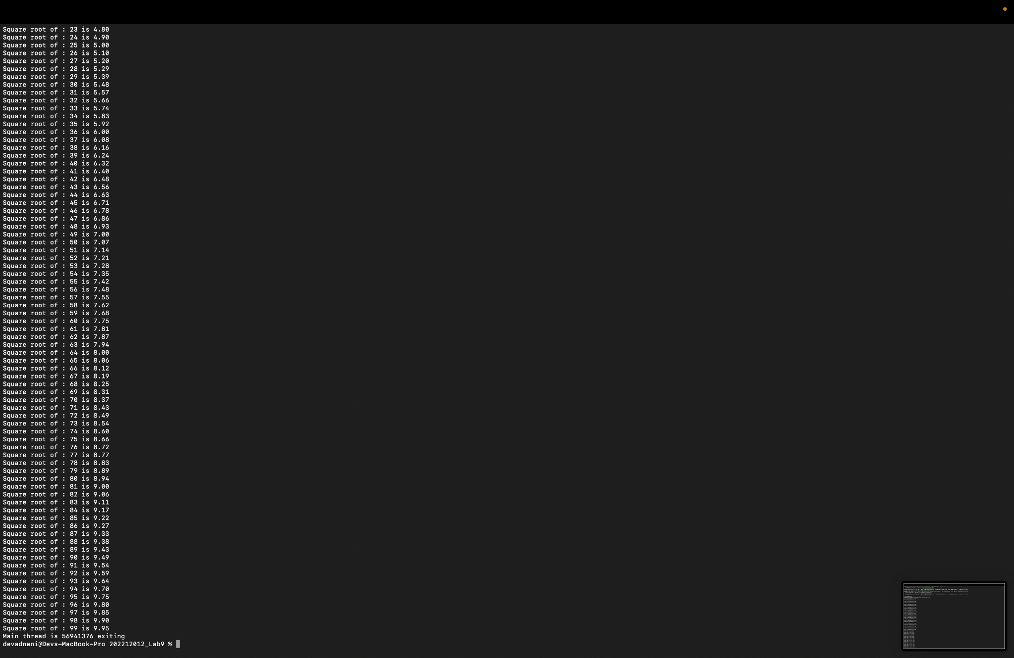

Q1 - C

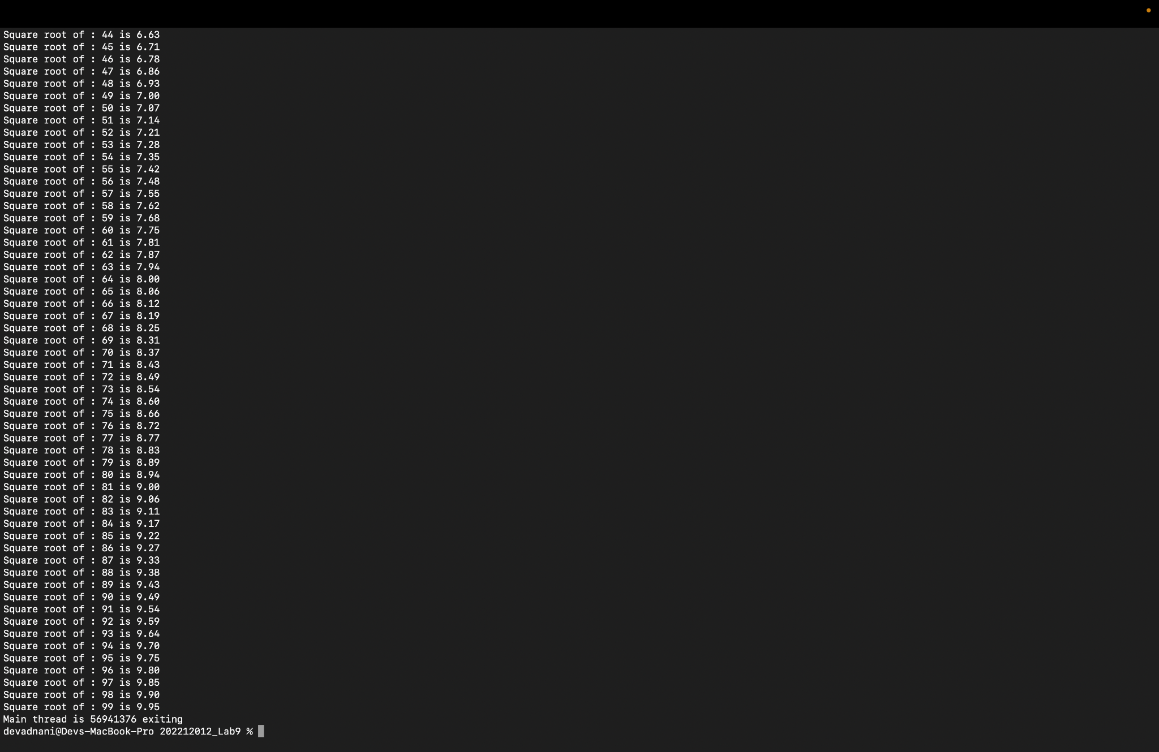

Q2 : 202212012_Lab9_2_parallel.c

#include <stdio.h>

#include <unistd.h>

#include <pthread.h>

#include <stdlib.h>

#include <sys/time.h>

#define ROW 500

#define COL 500

int mat[ROW][COL];

int cur_row = 0;

u_int64_t get_gtod_clock_time()

{

struct timeval tv;

if (gettimeofday(&tv, NULL) == 0)

return (u_int64_t)(tv.tv_sec * 1000000 + tv.tv_usec);

else

return 0;

}

void *calc_sum(void *arg)

{

int *num1 = arg;

int *local_sum = (int *)malloc(sizeof(int));

*local_sum = 0;

for (int i = 0; i < *num1; i++)

{

for (int j = 0; j < COL; j++)

{

*local_sum += mat[cur_row][j];

}

cur_row++;

}

return ((void *)local_sum);

}

int main()

{

u_int64_t start_time_value, end_time_value, time_diff;

int num_threads;

long long sum = 0;

for (int i = 0; i < ROW; i++)

{

for (int j = 0; j < COL; j++)

{

mat[i][j] = i + j;

}

}

printf("Enter the no of threads to create: \n");

scanf("%d", &num_threads);

if (num_threads > ROW)

{

printf("Number of threads must be less than %d\n", ROW);

return 0;

}

start_time_value = get_gtod_clock_time();

pthread_t threads[num_threads];

int n = ROW / num_threads;

int rem = ROW % num_threads;

int p;

int *val[num_threads];

for (int i = 0; i < num_threads; i++)

{

p = n;

if (rem != 0)

{

p++;

rem--;

}

pthread_create(&threads[i], NULL, calc_sum, (void *)&p);

pthread_join(threads[i], (void **)&val[i]);

}

for (int i = 0; i < num_threads; i++)

{

sum += *val[i];

}

printf("Total sum is %lld\n", sum);

end_time_value = get_gtod_clock_time();

/* Time difference */

time_diff = end_time_value - start_time_value;

/* display the difference */

printf("Time difference is %ld\n", time_diff);

}

Screenshot :

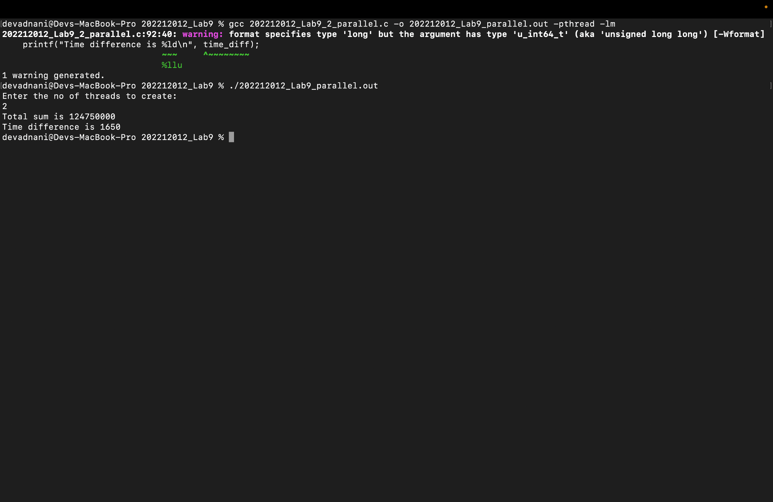

Q2-B 202212012_Lab9_2_serial.c

#include <stdio.h>

#include <unistd.h>

#include <pthread.h>

#include <stdlib.h>

#include <sys/time.h>

#define ROW 500

#define COL 500

int mat[ROW][COL];

int cur_row = 0;

u_int64_t get_gtod_clock_time()

{

struct timeval tv;

if (gettimeofday(&tv, NULL) == 0)

return (u_int64_t)(tv.tv_sec * 1000000 + tv.tv_usec);

else

return 0;

}

int main()

{

u_int64_t start_time_value, end_time_value, time_diff;

long long sum = 0;

for (int i = 0; i < ROW; i++)

{

for (int j = 0; j < COL; j++)

{

mat[i][j] = i + j;

}

}

start_time_value = get_gtod_clock_time();

for (int i = 0; i < ROW; i++)

{

for (int j = 0; j < COL; j++)

{

sum += mat[i][j];

}

}

printf("Total sum is %lld\n", sum);

end_time_value = get_gtod_clock_time();

/* Time difference */

time_diff = end_time_value - start_time_value;

/* display the difference */

printf("Time difference is %ld\n", time_diff);

}  
  
Screenshot :

